Main Model:

After doing literature review on basic SIR model, different extensions such as SEIR model, we started building a new model with more equations and more parameters based on features like vaccinations, mutant of virus, hospitalization, quarantine.

This is the final flowchart of the model:

<Add Model here>

These are the set of 9 differential equations and the parameters:

<Add equations and parameters>

Working of the code:

The project is coded in python using SciPy library to numerically solve differential equations. We obtained active cases of India during First and Second Wave (Reference: <https://www.worldometers.info/coronavirus/country/india/>)

The parameters were estimated using information from health organizations and optimization. The following plots were generated:

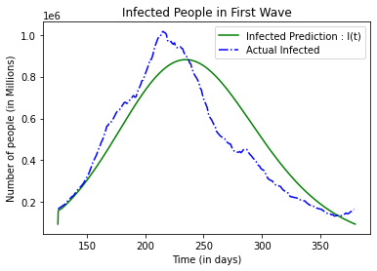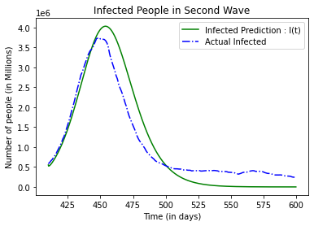

The plots of Extended SIER model depict the evolution of an  
epidemic with basic parameters representing rates of infection,  
recovery, hospitalisation, and death. Other parameters such as  
large public gatherings are also introduced. In the latter case,  
we can see a great increase in the number of hospitalised  
COVID-positive patients. In an on-ground situation, this could  
become a widespread issue if the number of hospitalizations  
exceeds the availability of beds. These models enable a richer  
understanding of dynamical models while serving as a great  
representative of real-life situati

For the plot below: \t_0 = 150, \t_1 = 200, k = 0.8

The plots depict the infected cases predicted by the model compared to the actual data from the sources for First wave and Second wave in India. Many basic parameters such as rate of infection, recovery, hospitalization and death are used, along with specific parameters like rate of vaccination, mutant virus infection, quarantine. The parameters are estimated using government sources as well as research papers, along with optimization. The results match fairly accurately with the actual results and further predicts cases for variation in the parameters. These models enable a richer understanding of dynamical models while serving as a great representative of real-life situations.